Add a Cinematic Lens to Daily Life: How to Craft Your Personal "Life Soundtrack"?
Imagine a typical morning: you pull back the curtains, and soft sunlight spills across the room. Or your daily commute: the rhythmic patter of raindrops against the car window. Perhaps it’s late at night, and you're washing dishes to the crisp clink of porcelain under running water. These moments aren't inherently "special," but the second you put on your headphones and press play, they suddenly gain a narrative texture. Ordinary life feels like it’s been passed through a cinematic filter, and everything becomes a bit more soulful.

Most of us have a habit of living life to a beat. Music is an emotional vessel; it helps us transform scattered daily routines into memorable vignettes. The right song at the right time can make a cramped morning rush hour feel less agonizing, soften the blow of late-night overtime, or fill the void of a quiet weekend alone. But there’s a catch: even the best songs eventually lose their luster.

Picture this: you’re craving a specific vibe—maybe some fresh, light-hearted Funk guitar strums to lift your mood. You ask Siri to "play some Funk," but it fails to grasp the nuance and blasts a high-energy Brazilian Funk track that scares you half to death. The jarring rhythm instantly shatters the delicate mood you were nurturing. You could go back to digging through your library, but that fleeting "moment" is already gone.

Try MakeBestMusic: From Curating to Creating Your Bespoke Soundtrack

What if there was a way to customize a "Personal Daily BGM truly"?

Imagine shifting from "picking and choosing" in a library to "generating" a piece of music based specifically on your current mood, setting, and desired atmosphere—a track that belongs only to this exact moment. Every ordinary second of your life could have its own exclusive score, and you’d never have to settle for a song that’s just "close enough" again.

This might sound like a luxury, but in 2026, it’s a reality. The maturity of AI music generation has brought this within reach. All you need to know is how you want to feel, and then describe it in words. The algorithms translate your intent into a combination of melody, rhythm, timbre, and emotion. Thanks to massive datasets, AI has mastered the mapping between "style" and "mood." When you say "soothing jazz," it understands exactly what chord progressions, rhythmic density, and instrumentation entail. This means every moment can have its own voice—and you are the creator.

Let me introduce you to my personal favorite AI music tool: MakeBestMusic.
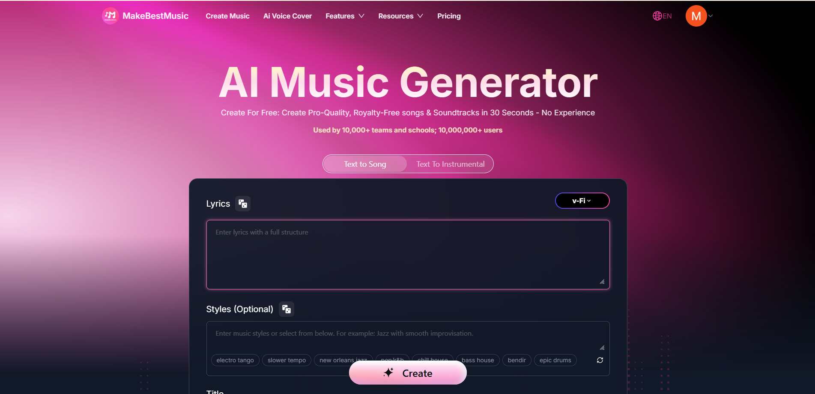
It is an AI music generation platform designed for everyone. It turns text descriptions into complete musical works, including melody, arrangement, rhythm, and vocals. You simply express "what kind of music I want," and the AI handles the rest. In the past, making a song required a team of professionals for composing, arranging, and mixing. Now, a few sentences in a text box give you a studio-quality track in minutes.

Here is how you can start scoring your life.
Scene 1: The Custom Alarm — Your Favorite Artist "Personally" Wakes You Up
Every morning, most people are jolted awake by the same mechanical, repetitive system alarm. It’s harsh and jarring, dragging you out of sleep into a reality you might not be ready for. Over time, you develop a Pavlovian distaste for that sound; before you’ve even opened your eyes, your mood is ruined.

But what if there was a better way?

Now, your wake-up call can be a piece of music created specifically for you—gentle melodies, a progressive tempo, a warm vibe—and most importantly, "sung" by your favorite artist. Not their latest hit, but a song that exists only for your morning. This sounds like a VIP privilege, but MakeBestMusic’s AI Voice Cover feature makes it possible.
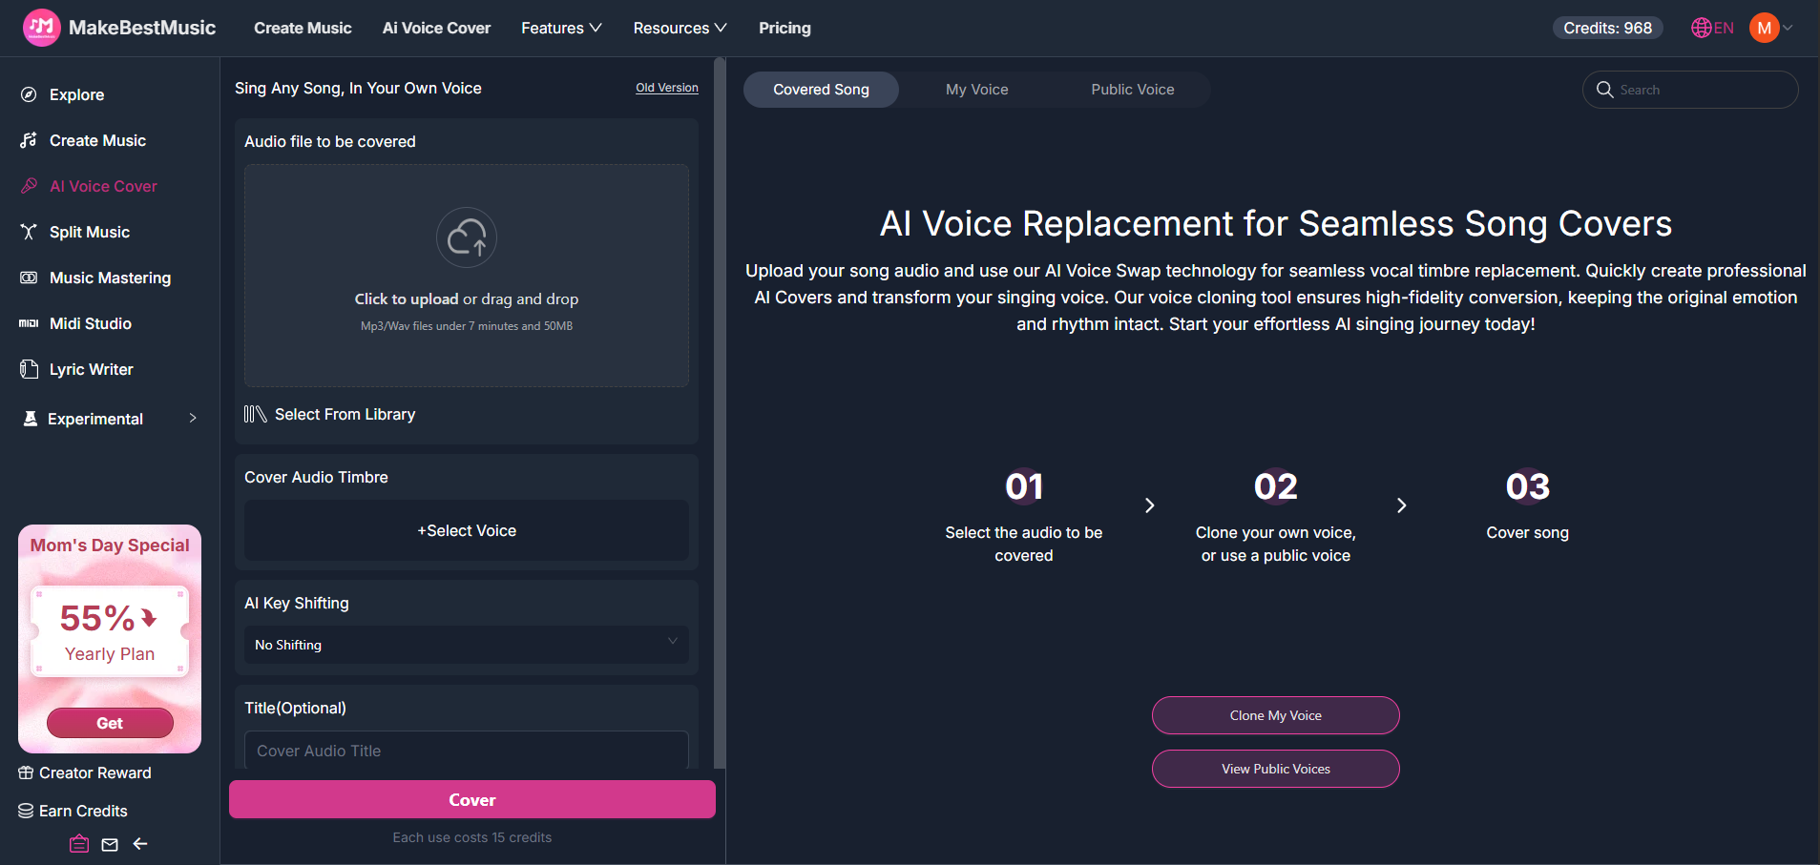
The core of AI Voice Cover is voice replacement. It can swap the vocals of any track with a specific voice model—either from the platform's public library or a voice you’ve uploaded and cloned. You can generate a perfect "wake-up" track on MakeBestMusic and then have your favorite singer perform it.

How to get started:

- First, let’s try generating a piece of music suitable as a wake-up track. Open the MakeBestMusic home page and select Create Music from the top navigation bar to enter the creation page. Select Simple Mode and enter the following prompt example in the description box: "A gentle morning song, soft acoustic guitar, warm and uplifting, slow tempo, gradually building energy." Click Create to submit.

- A few minutes later, you will get a piece of music that matches the description. Listen to it; if the melody and atmosphere meet your expectations, the next step is to switch it to your favorite singer’s voice. Let's enter the AI Voice Cover page. First, select the wake-up track we just generated as the source audio. After that, you can choose a voice model of a singer you like from the Public Voice Library.

- If you want a more personalized effect, you can also use the Persona feature to upload your own voice samples and clone your own voice model—this way, the person waking you up every morning could even be "yourself" singing a song, which will surely be quite a miraculous experience.

- You can also adjust the Key Shifting according to the characteristics of the selected voice model. If you want the voice to sound more gentle and soothing, you can choose Mellow / Soothing; if you want it to be more energetic, you can choose Natural or High Pitch.

Finally, click the Cover button to submit the task. In just a few minutes, you will receive a wake-up track sung by your specified singer's voice.

In the past, you could only pick songs created by others from existing music to use as an alarm, but now, you can create a piece of music that exists only for your morning. This kind of customized experience makes the act of waking up itself less painful. When you know that what awaits you every morning is a piece of music you designed yourself with warmth, the moment the alarm goes off might no longer be the worst moment of the day.

Scene 2: Midday Meditation and Relaxation — Lo-fi Music Helps You Quickly Restore Peace

Lunch break is only a short thirty minutes to an hour, but if used properly, it can become the most important recovery moment of the day.

However, even when many people lie down, it is hard for their brains to truly quiet down. The morning's work is still spinning in their heads, and afternoon to-do items make them restless. Although your eyes are closed, your consciousness is still in a working state. By the end of the break, you realize you just closed your eyes and soaked yourself in the fear of being unable to extricate yourself from the work state.

In times like these, what you need is not total silence, but a switch for "rest mode"—a type of music that can occupy your attention without stimulating your thinking. Lo-fi music happens to fit this requirement. Its rhythm is slow and regular, its melody is simple and repetitive, and its timbre is warm and soft. It’s as if it builds a soft barrier around your consciousness, isolating external interference and internal distractions. You don't need to actively "listen" to it; it’s just there like a piece of furniture, existing naturally like breathing, helping your brain switch from tension to relaxation mode.

But not all Lo-fi music is suitable for meditation. Some Lo-fi rhythms are too obvious, making people want to tap along; some melodies are too complex, which instead scatters attention; some timbres are too bright and lack that sense of being enveloped. What you need is a very pure, minimalist, and almost non-aggressive sound. It has no strong "flavor," but it’s just right—like a glass of warm water. This kind of precise demand is hard to satisfy by searching existing playlists. But if you know how to use MakeBestMusic’s style tag system, you can create a piece of Lo-fi music specifically for midday meditation in minutes:

How to get started: First, open the MakeBestMusic home page, select Create Music to enter the creation page, select Custom Mode, and toggle the Instrumental switch to ON.
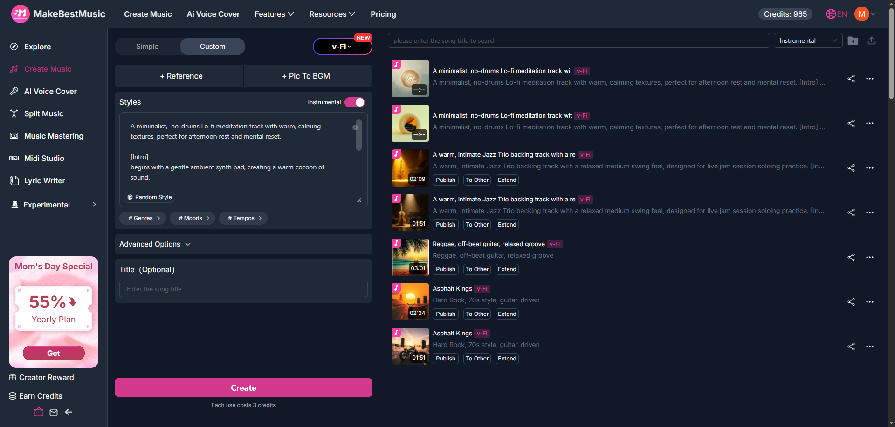
- In the Style input box, you can use Meta Tags to precisely control the structure and style of the music. Meta Tags are a standardized tag system provided by MakeBestMusic used to convey clear creative instructions to the AI. For meditation music, you can construct a style description similar to the following.

A minimalist, no-drums Lo-fi meditation track with warm, calming textures, perfect for afternoon rest and mental reset.

[Intro]
begins with a gentle ambient synth pad, creating a warm cocoon of sound.

[Verse]
introduces a simple, repetitive piano melody in a low register, accompanied by subtle tape hiss, establishing a meditative rhythm at 60 BPM.

[Interlude]
The piano continues its gentle loop while a distant, muted synth layer adds depth without demanding attention.

[Outro]
all elements gradually fade into silence, like consciousness gently drifting away.

- We can see that every element in this prompt is playing its part:

- A minimalist Lo-fi meditation track determines the basic style direction of the music.
- "60 BPM" locks in a very slow rhythm, close to a human's resting heart rate, which helps with relaxation.
- "The piano continues its gentle loop while a distant" specifies the instrument configuration—piano provides the melody, and the synth provides the background to create a sense of space.
- "No drums" clearly excludes drum beats to avoid a rhythm that is too obvious.
- "Perfect for afternoon rest and mental reset" is a direct explanation of the emotion and usage scenario.
- Meta Tags (such as [Interlude]) define its musical structure and layering, allowing the AI to understand your intent more clearly.

After submitting and generating, you will get a piece of minimalist Lo-fi music. When listening, observe if it truly allows your attention to "empty." If you find your attention actively following the melody, it means the music is not simple enough. You can go back to the Style description to further emphasize "minimalist" and "repetitive," or reduce the Weirdness value in Advanced Options.

Meditation music is not "the more complex, the better," nor is it "the quieter, the better." It needs to find a subtle balance between "presence" and "transparency"—it must be obvious enough to occupy your auditory space, yet simple enough not to interfere with your conscious flow. Through the combined use of Meta Tags and Advanced Options, you can adjust it like a precision instrument, gradually approaching this ideal balance point.

Compared to picking randomly from a playlist, you can decide whether the music includes drums, whether the piano tone is bright or soft, and whether the rhythm is 60 BPM or 70 BPM. These seemingly small differences directly affect whether you can truly relax in actual use. When you have this level of control, you will surely get the most relaxing nap you've ever had.

Scene 3: Rainy Day Commute — Sophisticated and Stylish Smooth Jazz
Commuting on a rainy day is always frustrating. Damp clothes and shoes, low pressure squeezing everyone. You look up, and outside is a gray sky; the windshield wipers move mechanically back and forth, and the traffic on the road is much slower than usual. You sit in your seat, feeling trapped in a narrow space with nothing to do, forced to just endure it.

But what if a piece of soothing Smooth Jazz starts playing in your headphones at this moment? The plucking of the double bass falls rhythmically like raindrops, the saxophone blows out a lazy and gentle melody, and piano chords softly spread in the background. Suddenly, those frustrating elements—the sound of rain, the movement of the wipers, the slow traffic—all become part of a certain cinematic quality. You are no longer an exhausted commuter trapped on the road; you are the protagonist in a certain indie film, experiencing a moment of slight melancholy but not lacking in style.

This is what the right music can do: it doesn't change reality, but it changes the way you perceive reality.

However, it is hard to find a piece in a music library that perfectly fits your mood at this moment. Either the rhythm is too fast, the emotion is too intense, or the instrument configuration isn't right—you want something soothing but not hypnotic, stylish but not pretentious, something that can relax your nerves from the morning tension without making you completely zone out. You need a very specific atmosphere, but perhaps each song can only satisfy one or two of your requirements. What should you do?

In such times, why not try creating a piece of Smooth Jazz specifically for a rainy commute using MakeBestMusic?

- How to get started: Let’s open the MakeBestMusic home page again, select Create Music to enter the creation page. Because we have relatively clear requirements for the style and atmosphere of the music, this time we select Custom Mode to describe what we need more accurately and comprehensively.
- First, we toggle the Instrumental switch to the ON position so that the input music will be pure music without vocals, as required. Then, in the Style input box, you can describe your desired music characteristics in detail. The more detailed your description, the higher the match between the generation result and your expectations.
- If you want to fine-tune further, you can open Advanced Options. Here, you can adjust the Style Influence parameter—the higher the value, the more strictly the generated music follows the description you entered in the Style box. For scenarios requiring precise atmospheric control, it is recommended to set Style Influence between 70-80, which ensures style accuracy while leaving some creative space for the AI to avoid being too mechanical. Finally, click Create to submit.

Below is another example prompt. You can modify and test based on its content to try and generate the effect you most want to present:

A sophisticated, calming smooth jazz instrumental for a rainy commute, featuring a relaxed 70 BPM tempo, warm tone, and a mood that turns the dreariness of rain into cinematic, reflective beauty.

[Intro]
Soft brush strokes on a ride cymbal and the gentle patter of muted piano chords set a laid-back, rainy-evening atmosphere. A subtle high-pass filter effect mimics the sound of music heard from inside a cozy car.

[Verse]
An upright bass enters with a slow, walking pulse, its deep, rounded tone providing a steady anchor. A tenor saxophone plays a breathy, uncomplicated melody—unhurried and introspective, with just a hint of blue. Behind it, quiet Rhodes electric piano chords wash over like raindrops on glass.

[Interlude]
The saxophone retreats, leaving a dialogue between the bass and the Rhodes. A soft jazz guitar plays sparse, clean arpeggios with a slight reverb, and the brush drums maintain a featherlight shuffle. This section is meant to evoke the meditative rhythm of windshield wipers.

[Outro]
The saxophone returns one final time with a quiet restatement of the main theme, now even more understated. The instruments gradually drop away—first the drums, then the piano—until only the bass and a lingering ride cymbal shimmer remain. The final sound is the distant, fading resonance of a piano chord, like the rain finally letting up.

A few minutes later, you will receive a piece of Smooth Jazz pure music that matches your description. You can listen to it first. If the overall atmosphere meets your expectations, but you still want to adjust certain details (for example, you want the saxophone to have a stronger presence, or you want the rhythm to be a bit slower).

You can also find the music you want to adjust in the generated music list on the left side of Create Music. Click the ellipsis on the left, select ReCreate from the list, return to the Style description to make the corresponding modifications, and re-generate a new version based on the previous one. Traditional music recommendation systems can only guess what you might like based on your past listening records, but they cannot understand what the "current you" needs immediately. When you use words to describe specific scenes, emotions, and atmospheric needs, AI can directly generate a piece of music tailored for that moment you described.

Compared to searching for existing Smooth Jazz playlists from a music library, now you only need to spend two minutes describing the feeling you want and then wait for the AI to turn it into reality. Now, try to recall a "moment" from your past and try to make a unique BGM for it.

Summary: Use MakeBestMusic to Make Music a Part of Life

What MakeBestMusic does is turn "selecting songs" into "creation." You no longer need to find the one that is "close enough" from a playlist; instead, you can create a "completely suitable" piece of music for every life scene. Morning alarms, rainy commutes, midday meditation—and even more than that—every moment of yours can have its exclusive sound, and these sounds are all customized by you. When you can create a score for life at any time, music is no longer just a pastime or background; it becomes a way for you to express yourself and shape your daily experience. Your life soundtrack should not be determined by an algorithm's recommendation; it should be written by you.

Try opening MakeBestMusic and making a song for a certain moment today. It doesn't need to be perfect or professional; it just needs to honestly describe the feeling you want at this moment. Then press the play button and listen to the sound it created for you. Perhaps you will find that those ordinary daily moments have actually always been worth becoming beautiful memories.

